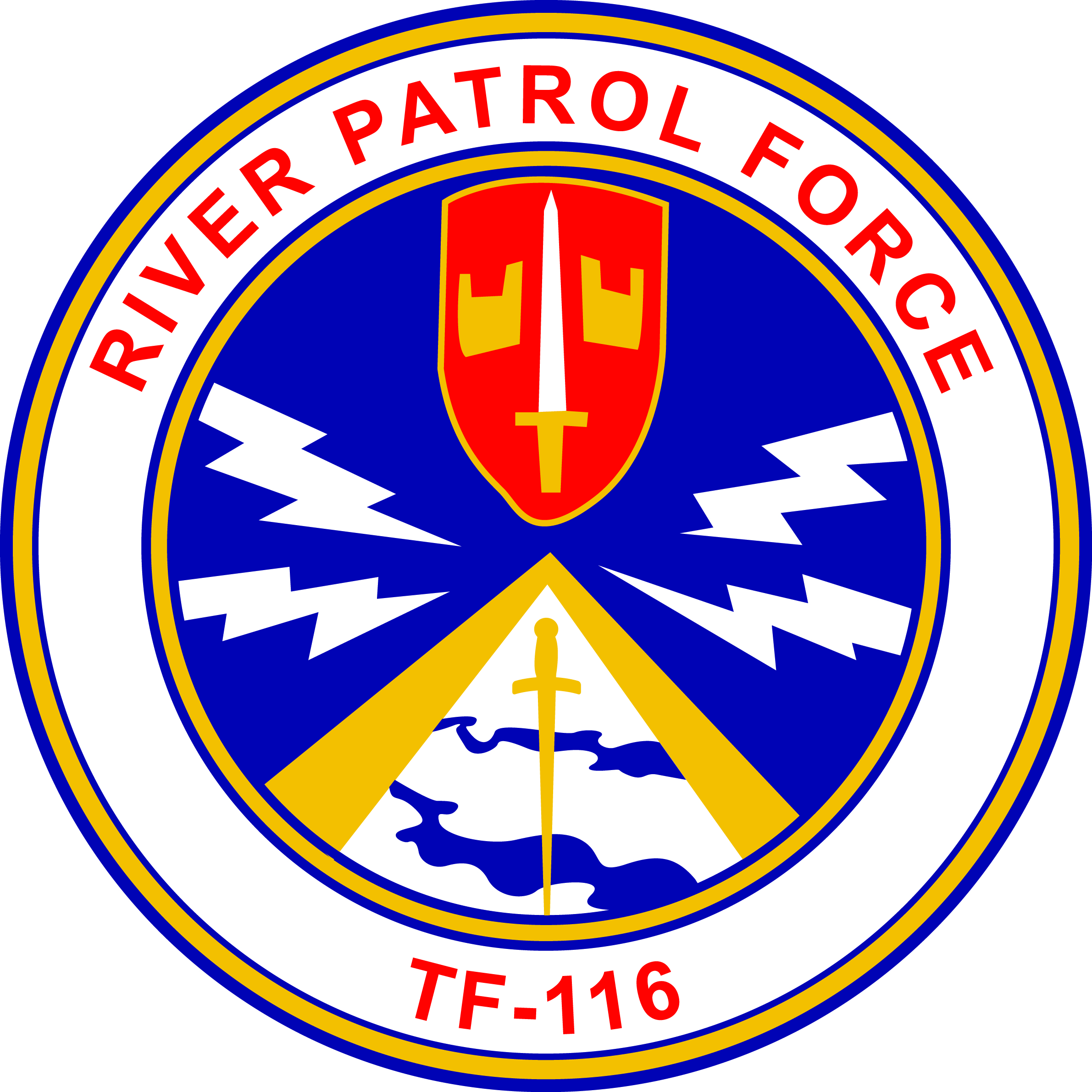
Gamewardens Association
Vietnam to Present
Formed December 18, 1968
(DBA)
Gamewardens – North West Chapter
Formed September 2005
A not for profit 501-C-19 Veterans Association

After Action Report
For May 18th, 2019. Bremerton Parade
Submitted this date May 24th, 2019

Ahoy River Rats and Friends !

Your Hot News from the NW:

- Bremerton Armed forces day Parade, Saturday, May 18th
What a great day for a Parade! Those attending, a great group.
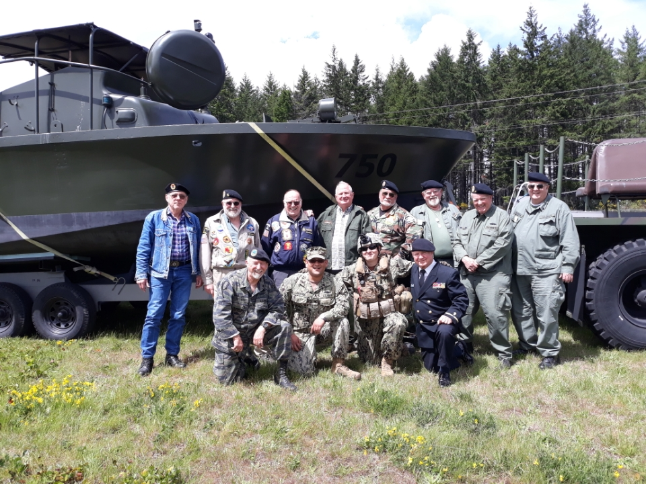
Jack Weaver, Heinz, His Brother, Joel Leavitt, Steve, Richard Linn, Bern Smith, Mac
In front: Bob, Carlos Landaverde CRS11, Eryk Maroon CRS1 and Wayne Palmer
Mac’s wife Dorothy is the photographer
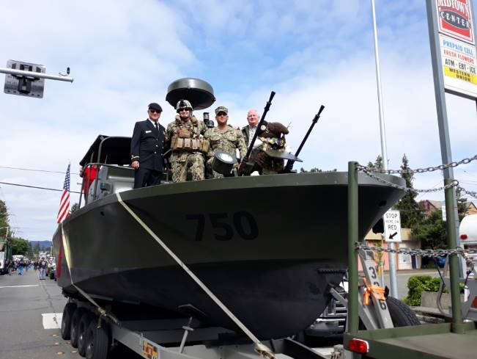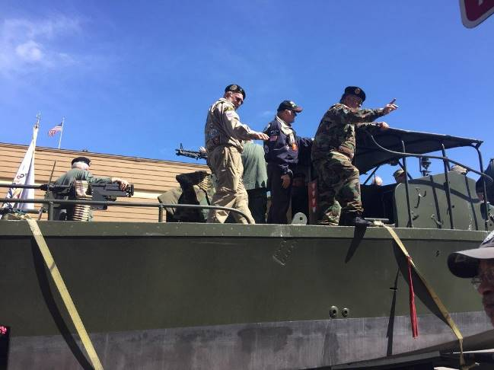
Old and New “river rats” Well received by a great crowd!
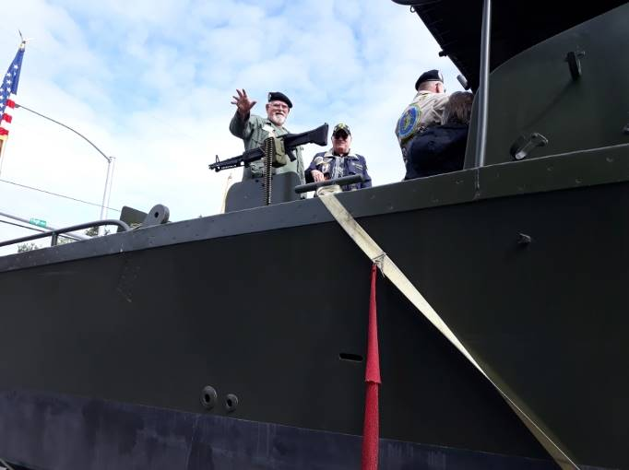 Richard Linn working his parade wave.

- Des Moines Boat Lift and Engine burn off.
We moved the Boat from Bremerton to Des Moines on Monday to lift the boat into the
water for the engine burn off and injector adjustments. Pacific Power had their technicians, Tom McMullen and Andrew Doyle, do the critical adjustments and our Jamie Welsh was at their side. After two on the water runs, the boat got up on step with little effort. Jamie is to shim the governor for more RPMs and we will be running fast for this summers “on the water” events.

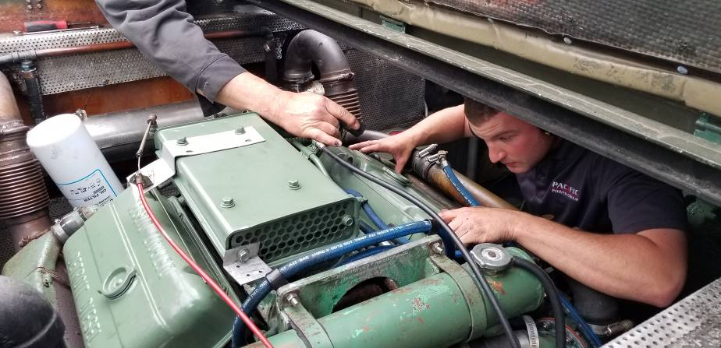
Andrew Doyle, of Pacific Power, doing last minute adjustments. As you can see he fits in there.
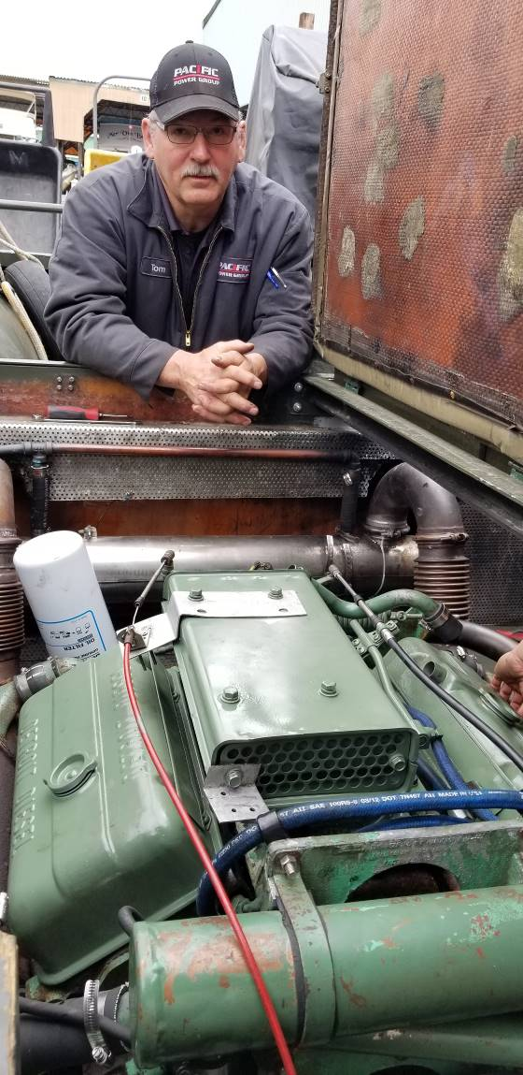 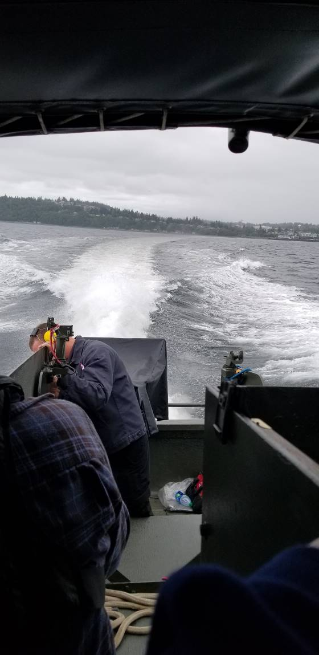 Tom McMullin took a personal interest and donated many hours of labor to get us up and running. An “on the water” mini patrol is in the cards for this summer.

3) Our next Activity: Mark your calendars!

Coastal Riverine Squadron 1 leadership awards June 8th, 1100-1500

Four Berets will be presented to “deserving” active duty river rats at the CRS1 family BBQ and leadership awards program at Swan Island, portland . Those of you that are planning to be there representing the chapter be sure to provide me your names and we will get those to the gate for easy access. We will car pool if at all possible. We’ll meet the families of these active navy men, have our ships store available and share a burger or two.

4) Our Second June Activity: Mark your calendars!
Olympic Air Show (Static Display) – June 15th and 16th

The air show is always well attended and we need help with this static Display.
We need enough of you to spell the guys giving tours of the boat for these two days.
We will try to get some housing set up in the area that should help.
Chapter Finances!
Again, I want to congratulate the chapter members that have stepped up and helped with the annual budget on a month to month basis. We will be able to raise funds at the summer activities and thereby secure a good financial footing for the coming year. Thanks for helping us out guys, let’s keep supporting our history.

Take care and will see you soon,
Steve Sumrall, Pres., Peter Lahmann, V.P., Bob Brower, Sec. / Treasurer (see more below)

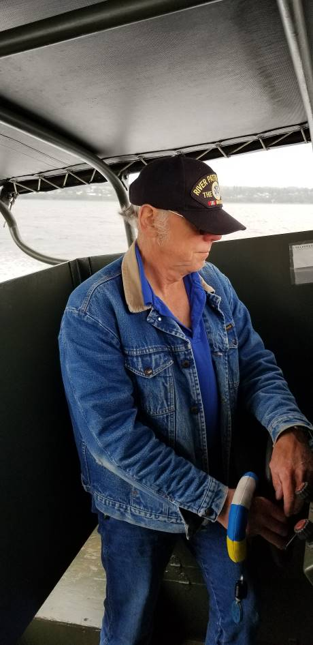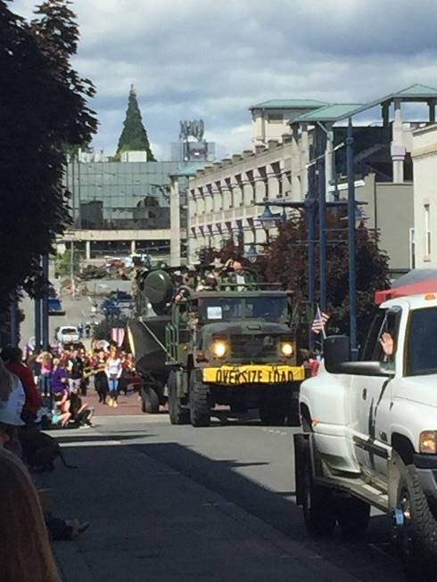
Jack Weaver, Truck driver and boat pilot
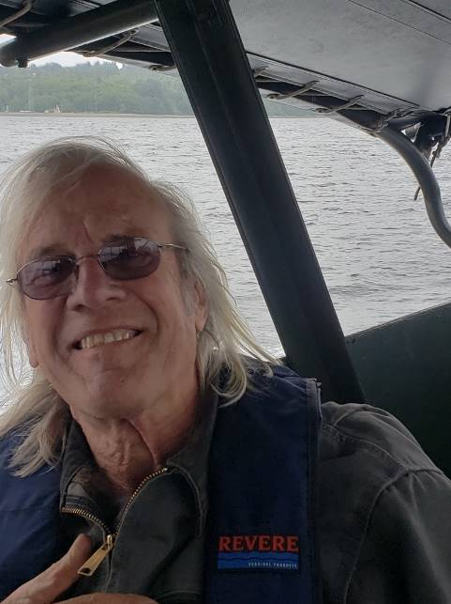 Bruce Wiedemann, our chapter engineering Tech, functioning 40mm Honeywell designer and fabricator. He is a “Jack of many trades”.

