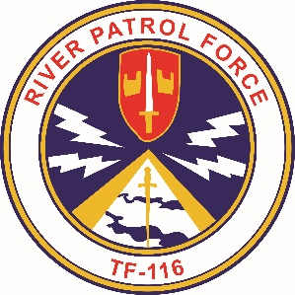
Gamewardens Association
Vietnam to Present
Formed December 18, 1968
(DBA)
Gamewardens – North West Chapter
Formed September 2005
A not for profit 501-C-19 Veterans Association

Rat’s nest Location: 1595 N. National Ave, Chehalis, WA. 98532
After Action Report (No Mail delivery)
For June 16th , and 17th , 2018, Olympic Air Show.
Submitted this date June 24th , 2018

Ahoy River Rats and Friends !

Your Hot News from the NW:
This last weekend was spent with the OP boat in static display at the Olympic Air Show. Friday
morning Pete led the procession of our utility trailer, Jamie Welsh drove the 5ton with the PBR in tow from the Rat’s Nest. I followed with the Hydraulic stairs and we spotted our equipment in the display 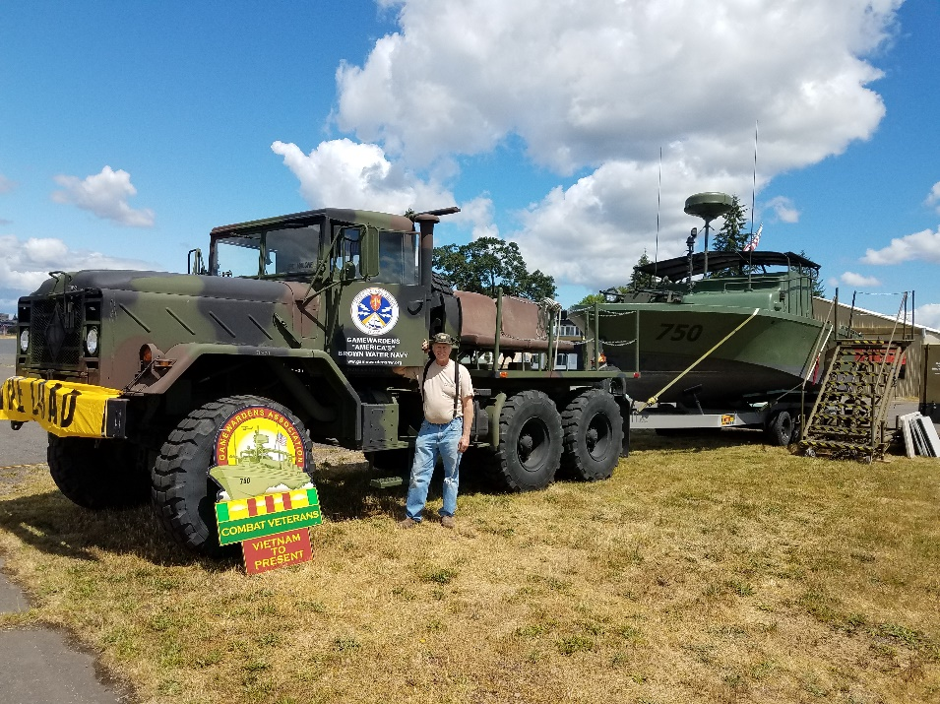 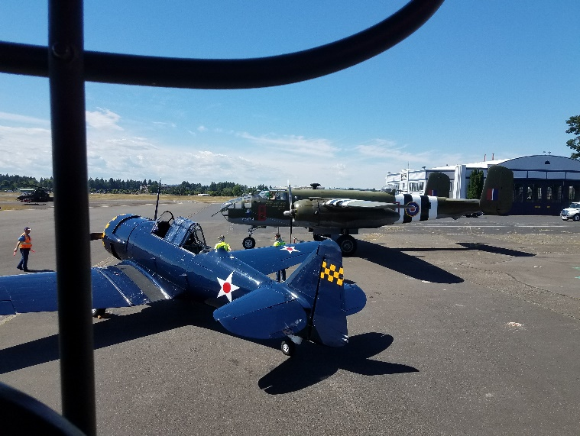 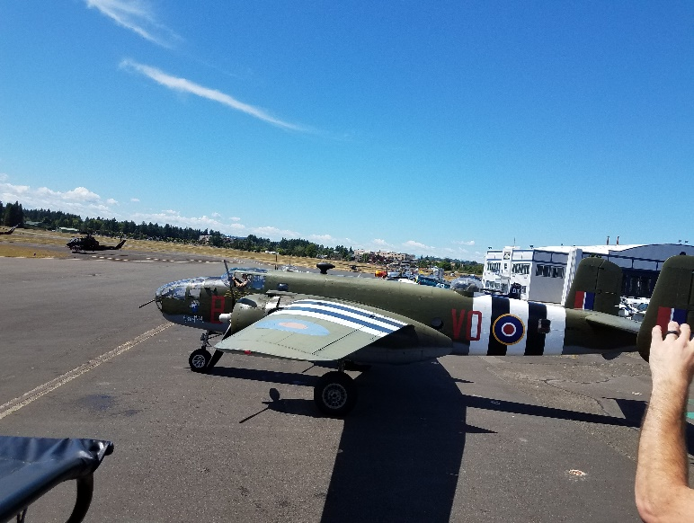

Manning the display for Saturday and Sunday were: Steve Morrison, Larry Johnson, Bill Gifford Heinz Hickethier, Ward “Bern” Smith, Gary Larson, Jamie Welsh, Mac McCormick and Dave Perry visited for a short time health permitting him. We hosted hundreds of the public wanting to have a better understanding of our Vietnam experience and many supported our efforts by donating to our boat fund. Many hats and t-shirts were sold. If you have not ever attended the Airshow I highly recommend it. There is not much of a chance to view a flying B25 Mitchell Bomber of WWII fame or see a jet powered dragster win a race against a cobra gunship in a ¼ mile, but it’s all there…what a roar !

4th of July !!
- Centralia (Static Display) and Parade & (Pete’s Famous BBQ luncheon)-Wed, July 4th

We are planning again this year to attend the Centralia military display at Fort Borst Park just
a half block west of exit 82 of the I-5 freeway. We will attend the free breakfast there at 8:00am Saturday morning after moving the OP boat and hydraulic stairs from the Rat’s nest at 7:30. At 12:00 we will move the boat to the parade staging area between the 400 and 600 block of Centralia College Blvd. There is parking at that location. Those that want to ride the boat in the parade can meet at that location. We have been invited to Pete’s famous BBQ at his home ( 311 N. Iron St., Centralia ) The parade starts a 4:00pm. After the parade we will drop off at the staging area for your cars. The boat and stairs will be taken back to the rat’s nest at that time. Everyone will have time to get to the best fireworks shows for the evening.
So far I have attending: Steve Morrison, Heinz Hickethier, Ward “Bern” Smith, Bob Brower and myself. I’m still confirming a driver.

July 14th Work Party!!
Don’t forget and plan to attend the work party in July !
- Work Party – Saturday, July 14th (Prep for the Tacoma Maritime Festival)
We will meet for breakfast at the Main Street Grill at 8:00am.
(719 W Main St, Centralia, WA 98531)
We will start our work party at 9:00am at the Rat’s Nest. Lunch will be about 1:00 pm. We
normally break up about 2:30 or 3:00pm. We do need some manpower to help us unbox from our move into this location and we will have projects to work to ready the boat and trailer for the Maritime Festival at the end of the month.

Chapter annual calendar has been updated!
Be sure and make note of the summer activities on the new calendar and mark you
vacations accordingly.

FYI:
For those of you that are planning to attend the national reunion in Charleston Sept. 26th thru 29th. be advised the rooms are nearly spoken for so get your reservations made soon.

Chapter Finances!
With monies earned from the Rose Festival and from last week’s Olympic Air Show our budget is stable at present thanks guys for your financial support to keep us afloat.

Our Coming Attractions!

- July 28 & 29th will be the Tacoma Maritime Festival….so mark your calendars and also
- The 50th Vietnam Commemoration Event @ JBLM Museum – Saturday, August 11th

Should be fun

We have plans to support the JBLM Museum and commemorate the 50 years since our service to our country in the Vietnam conflict and honor those of our brothers that gave their all to this country. We will have the OP boat there at the Museum in static display. The public will have a way to visit without the rigors of getting gate passes.

Current & Future Projects!
- Infector repair of the port engine this next week.
- We are planning to modify the door of the Rat’s nest to allow access of the both boats. They are currently in open bay.
- Work to the J-boat painting hull, installation of engines and pumps.
- Painting of the Kiln walls white for better lighting.
- And many more.

Take care and will see you soon,

Steve Sumrall
President NW Chapter
253-3778007

