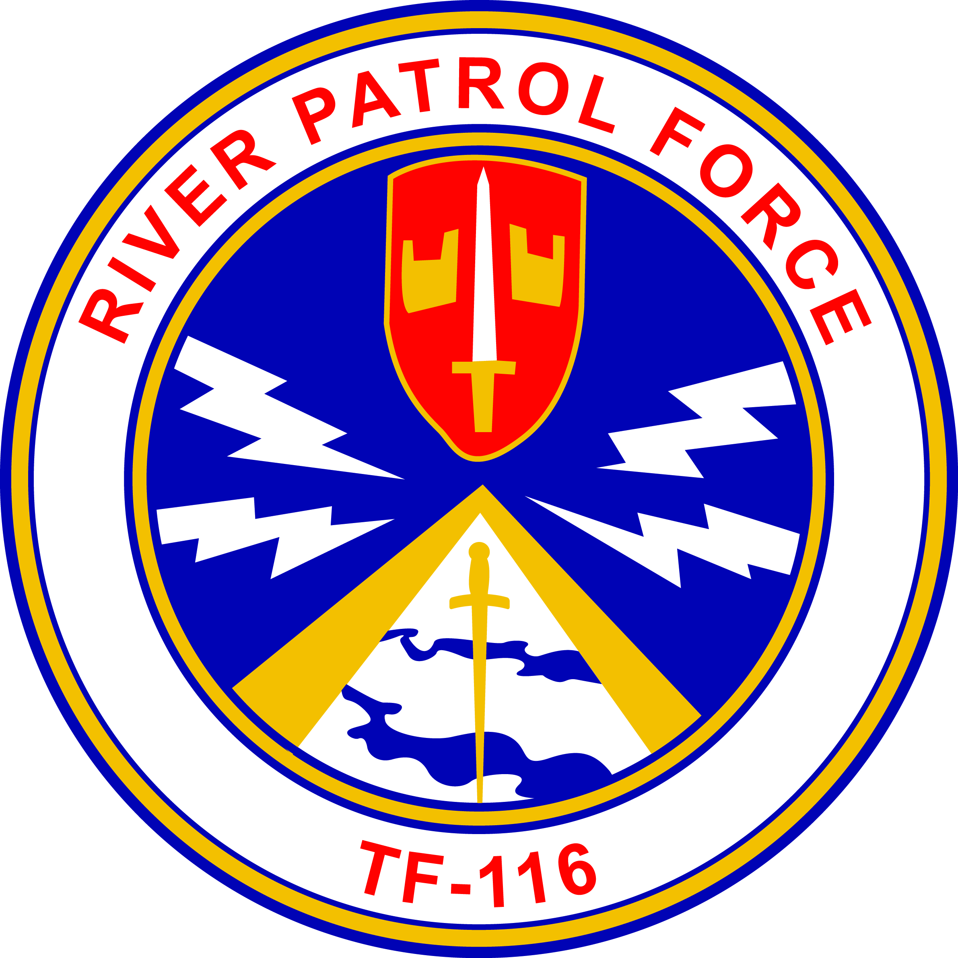
Gamewardens Association
Vietnam to Present
Formed December 18, 1968
(DBA)
Gamewardens – North West Chapter
Formed September 2005
A not for profit 501-C-19 Veterans Association

After Action Report
For June 8th, 2019. CRS 1 leadership awards and Family BBQ
Submitted this date June 11th, 2019

Ahoy River Rats and Friends !

Your Hot News from the NW:

The chapter attended the Coastal Riverine Squadron 1 leadership awards
and Family BBQ this last Saturday.
A Billy Rat was well receives by many of the youngsters as usual. We sold a few hats
and tee shirts and provided some navy history to many of the new members of the squadron using our story boards. The photo albums were of interest to many giving a since of what the brown water navy was involved in, in the Mekong Delta of Vietnam those many years ago.
We were Honored to witness and participate in the squadrons rank advancements, Leadership Awards presentations and beret presentations. I was honored to put a black beret on CPO Eryk Maroon’s head.
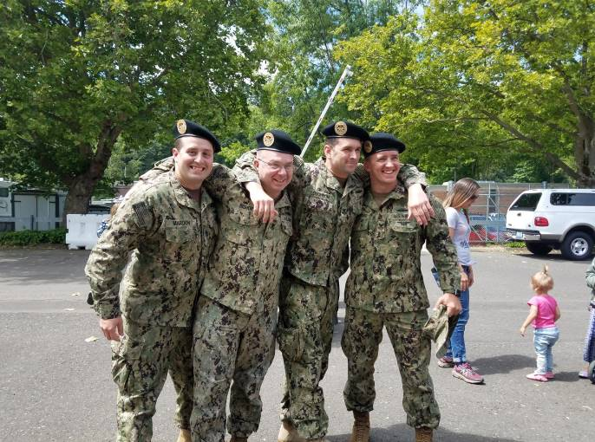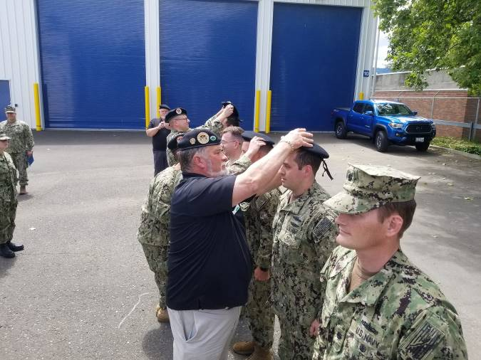
Those receiving beret this year were:
CPO Eryk Maroon, HM1 Joshua Bishop, MM1 Robert Loughbom, GM1 Chris Montiejunas
and Commander Chris Newmann

Congratulations to you black beret recipients!
Eryk was tasked to recruit his “soon to be born” son into the Navy and one day present a black beret to him. We gotta keep this history going!!

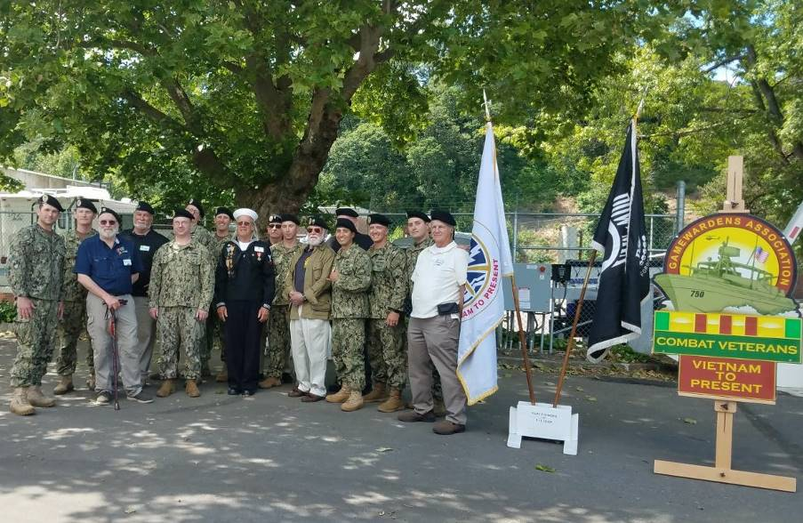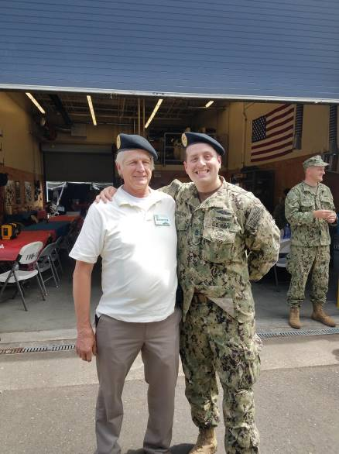
Gamewardens NW Chapter members and CRS beret recipients
The “brown water” Navy and “river rat” history continues!

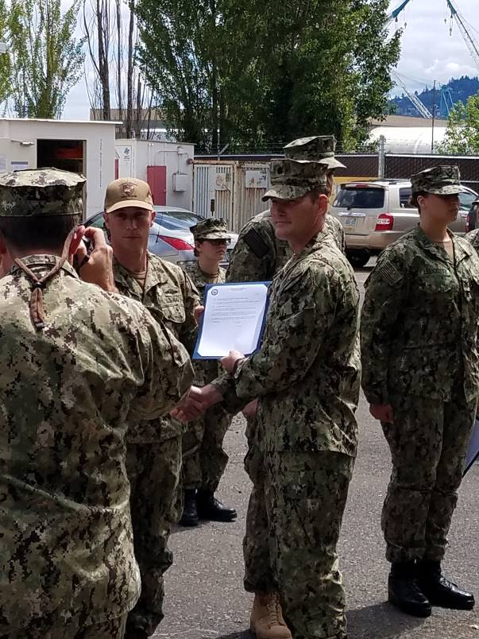 ACC Eryk Zimmerman being promoted to ACCS “Senior Chief “

1) Our next Activity: Mark your calendars!

Olympic Air Show (Static Display) – June 15th and 16th
The air show is always well attended and we need help with this static Display.
We need enough of you to spell the guys giving tours of the boat for these two days.
We will try to get some housing set up in the area that should help.
The uniform of the day is greens if you have them an d your Berets. Bring your
Name tags if you have them.
Bob, Jamie and I will meet at the rats nest at 9am Friday to move the boat, utility trailer and hydraulic stairs to the airfield in Tumwater. We should be there about 10:30 or 11:00. Help setting up the canopy and tables at that time would be appreciated. Don’t forget to being a couple of folding chairs. We seem to always be short on chairs. I will have an ice chest for drinks, etc. The public is always interested in our picture albums so please bring them.
The gates open at 9:00am at the airfield and close at 4:00pm. Come thru the gate and say that you are with Gamewardens (the code word) and move your vehicle to our display.
Offload, then move your vehicle back out to the designated “display area” parking.

Chapter Finances!
Again, I want to congratulate the chapter members that have stepped up and helped with the annual budget on a month to month basis. We will be able to raise funds at the summer activities and thereby secure a good financial footing for the coming year. Thanks for helping us out guys, let’s keep supporting our history.

Take care and will see you soon,
Steve Sumrall, Pres., Peter Lahmann, V.P., Bob Brower, Sec. / Treasurer

